1. Design PDA using simulator to accept the input string anb2n

INPUT:

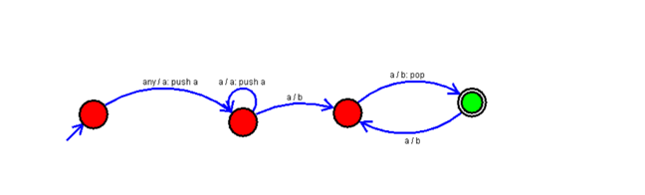

OUTPUT:

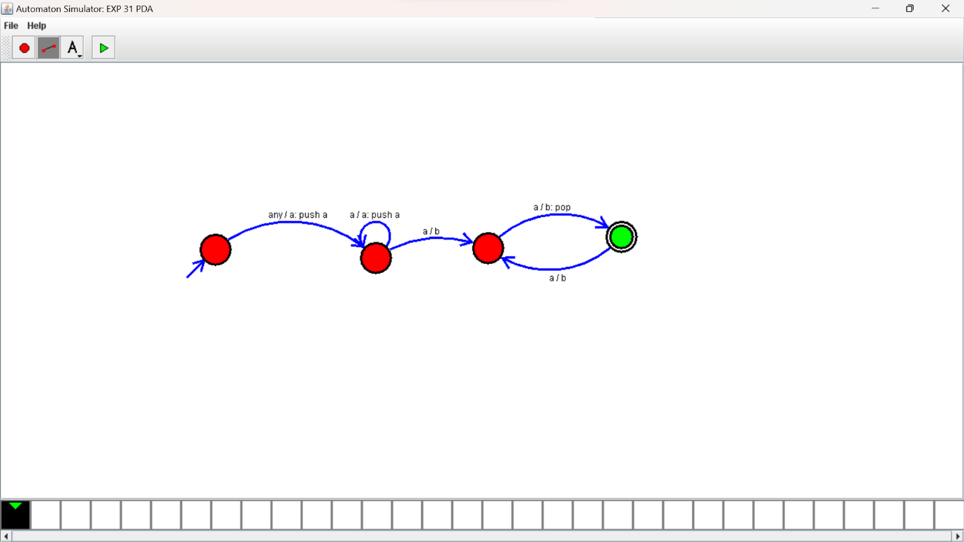

RESULTS:

PDA using simulator to accepting the input string anb2n